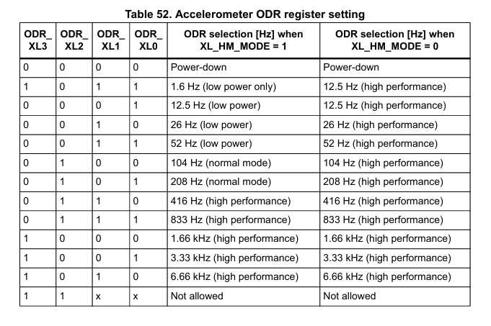

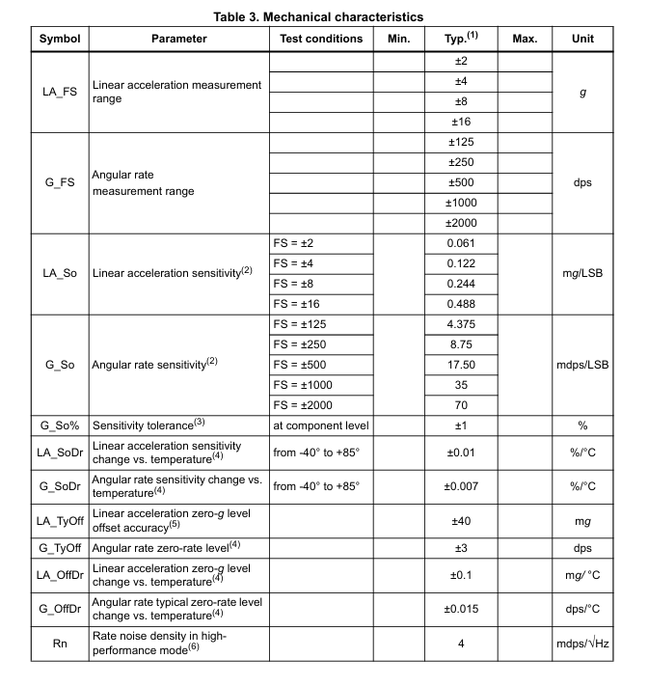

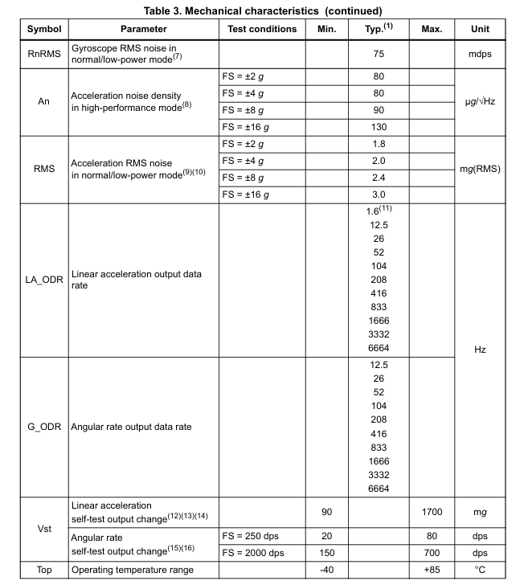

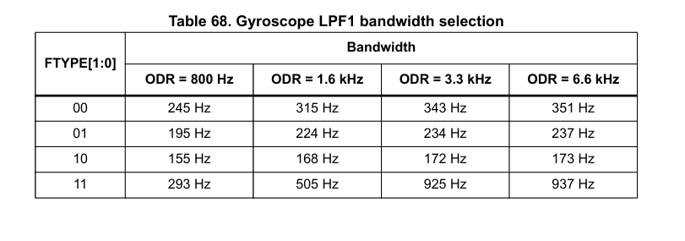

Accelerometer Parameters (from Table 3):

1. **Measurement Range**: ±2/±4/±8/±16 g → Use ±4g (39.24 m/s²)
2. **Sensitivity**: 0.122 mg/LSB at ±4g → 0.122e-3 * 9.81 = 1.196e-3 m/s²/LSB
3. **Zero-g Offset**: ±40 mg → 40e-3 * 9.81 = 0.3924 m/s²
4. **Noise Density**: 80 μg/√Hz at ±4g → 80e-6 * 9.81 = 7.848e-4 m/s²/√Hz
5. **Bandwidth**: ODR-dependent (Table 52)

Gyroscope Parameters (from Table 3):

1. **Measurement Range**: ±125/±250/±500/±1000/±2000 dps → Use ±250dps (4.363 rad/s)
2. **Sensitivity**: 8.75 mdps/LSB at ±250dps → 8.75e-3 * π/180 = 1.527e-4 rad/s/LSB
3. **Zero-rate Level**: ±3 dps → 3 * π/180 = 0.0524 rad/s
4. **Noise Density**: 4 mdps/√Hz → 4e-3 * π/180 = 6.981e-5 rad/s/√Hz
5. **Bandwidth**: ODR-dependent (Table 68)

* Consistent unit conversions (g → m/s², dps → rad/s)
* Corrected noise density units (μg/√Hz → m/s²/√Hz)